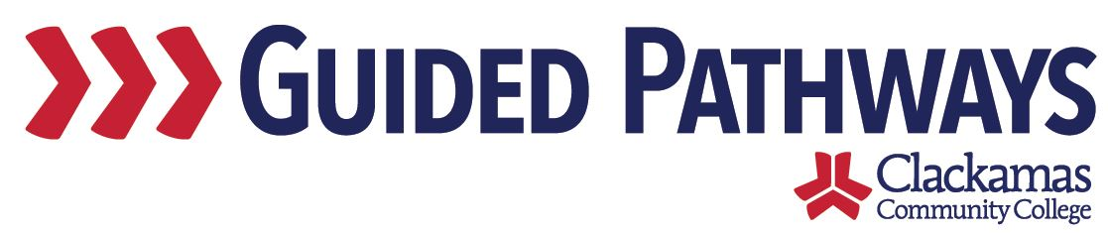
Guided Pathways Leadership Taskforce
Meeting Notes
July 2, 2018
2:00 – 3:30 p.m.

- Follow up on previous commitments
All three prior commitments have been completed. These are: David sending out the Key Performance Indicators (KPIs) to the taskforce, Tara talking to Loir about forming a communication workgroup, and David checking with Jil/Elizabeth about one of them participating in the taskforce.

- GP Organizational Chart
Max shared an updated organizational chart, which can be located on the Moodle under workgroups/resources. It includes updated names and titles. A few updates were offered, including:
- Changing Brittany’s area from A&S to AFaC
- Changing Roni’s area from TAPS to CBI
- Removing the “TBD psych” from Pre-college

As additional changes to the workgroups occur, Max requested that the edits be sent to Eboni and Nora. They will maintain and update the org chart.

- Nan Poppe monthly call check-in
David, Eboni, Nora, Carol, Max, Sue, and Tara participated in a call last week with Nan Poppe, our guided pathways coach. The agenda for the call included: Planned summer work; Updates on Collaborative Advising and Curriculum Projects; Plans for ongoing campus engagement; Reviewing rest of action plan; and other campus updates.

Nan said that she liked our FAQ and bookmark. David said that she asked if she could share with the other schools in our cohort. Nan said that we are making good progress on educational focus areas toward the 19-20 school year. She said to make sure we are reaching out to employers about changes – using advisory committees and Tim can discuss when he meets with districts and employers. She wanted to know if we are reaching out to high schools about guided pathways. On the topic of campus engagement, the coffee chats and bookmarks were discussed. She liked that we have folks from marketing involved. According to Nan, we are ahead of the other four institutions in our cohort (Rogue, Southwest, Lane, Chemeketa). She is positioning us as a resource/leader for those institutions.

- Project Management check-in
Max and Carol are meeting every week this summer, working on some specific deliverables. For inservice, they are working on a timeline document that this group has approved that is available to use. This will be a big picture view, leading eventually to a much larger document for the taskforce with all of the pieces built in. Over the next few weeks, Carol will be setting up meetings with project managers (and leads, if necessary). They will be having conversations about the work of the workgroups. The goal is to have those meetings done by July 23. On July 31 there is a meeting with workgroup leads and project managers to discuss/workshop a timeline. The goal is to have the timeline printed by September 10.

- Institute check-in
David participated in a recent peer group call with other vice presidents from the community colleges participating in our taskforce. There was discussion around the sorts of topics we are interested in covering at upcoming institutes. Equity and its relationship with guided pathways rose to the top – David reinforced that that is something we are interested in. Hearing from other colleges about how their advising systems work was another topic. The next institute is in November (hosted by CCC). There will be a core group that is attending every institute and some others that will attend depending on the topic.

Commitments:
- David committed to sharing who is participating in the November institute at the 8/6 taskforce meeting

- David check-in on 18-19 leadership taskforce involvement
David said that the Guided Pathways Leadership Taskforce can take more of a public role in implementing guided pathways. He said that h needs to delegate some things that he may have been doing in the past to other on the taskforce. He has a monthly meeting with the chairs and the project managers, where they are able to ask for any assistance or support they may need. David will continue to communicate about the taskforce with the Executive Council and Board (and communicate from Executive Council and the Board back to this taskforce). Eboni said that the Doughnuts with David and Pizza with Plotkin events were helpful for engaging those outside of the taskforce in this work. David said that he will continue those activities in 2018-19, but that he would like to tap others from this taskforce to facilitate those conversations.

- Workgroup updates
Dustin provided updates on the Collaborative Advising workgroup:
- Nothing new since last meeting
- Presentation to InSS deans tomorrow – make sure we’re on the right track
- Jennifer and Dustin will be meeting regularly to be ready for fall term

Lori provided updates on the newly-formed Communication workgroup:
- Tara and Lori will be meeting soon to discuss Lori’s role
- Fall Inservice – with Bill leaving and Tim starting – muddy area as we plan for inservice

Sue and Lisa provided updates on the Curriculum workgroup:
- Sue provided a handout:
- Used FYE classes to get feedback on draft EFAs
- Using the word “technology” too many places
- Down to 8 draft EFAs
- At some point we’ll want icons to go with each, along with a couple of sentences of text, send that back out to FYE students for additional feedback
- Few faculty over the summer who have offered to help with mapping – look at how things are coming together
- Lisa can report out at September meeting on mapping
- Sue can report out at August meeting on the EFAs (icons, text)
- Sue welcomes feedback

Tara provided updates on the Navigate workgroup:
- Navigate Student has launched – 350 new users
- When we have the ability to schedule appointments with advisors, that will increase regular use
- Dustin is working on staff advising side of it
- Started a small team looking at Early Alert (Jennifer, Chris, Jim) – looking at demos from EAB and then EAB will be onsite in August
- Advising team will be doing biweekly training starting next week – scheduling/cancelling appointments, syncing with Outlook
- Working with EAB to ensure accuracy
- Kiosk systems – when the student comes to check in – they’ll enter their ID number or swipe their card, put them into a queue to meet with an advisor

Darlene provided updates on the Pipeline workgroup:
- Darlene provided a handout:
- Irrigation technician (IET) program
- Fall term is the time to build curriculum, talk about logistics
- Rolling something out and building the model

- Review commitments and next steps
For the August meeting, Eboni asked everyone to think about how they (and their students) interact with the website. What would be some good things to ask Kim Crane to help us with? What are the things we want to make sure don’t fall through the cracks?

The next taskforce meeting is on Monday, August 6, 2:00-3:30 p.m.

